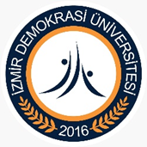
İZMİR DEMOCRACY UNIVERSITY
SCHOOL OF FOREIGN LANGUAGES
2025–2026 PREPARATORY PROGRAM JANUARY PROFICIENCY EXAM ANNOUNCEMENT
· January Proficiency Exam of our university will be held on January 13–14, 2026 at İzmir Democracy University Kemalpaşa/Ulucak Campus. The exam consists of two stages. Only students who score 65 or above in the first stage will be eligible to take the second stage. A summary of the exam dates and times is as follows:
First Stage – Multiple Choice Section:
January 13, 2026, between 10:00 and 11:30, at İzmir Democracy University Preparatory School Building.
Second Stage – Writing Section:
January 14, 2026, between 09:00 and 09:45, at İzmir Democracy University Preparatory School Building.
Second Stage – Speaking Section:
January 14, 2026, starting at 10:00, to be conducted at the İzmir Democracy University Preparatory School Building at individually assigned appointment times.
Please follow all announcements on our website ydyo.idu.edu.tr and on the notice boards at the entrance of the Preparatory School Building.
Exam Details:
Stage 1:
This stage consists of 60 multiple-choice questions covering Listening, Use of English, and Reading. The exam will start at 10:00 on January 13, 2026, and the duration is 90 minutes. Sample questions can be found on our website:
https://ydyo.idu.edu.tr/contb.aspx?No=3413 The exam hall arrangements for the first stage were made in accordance with the survey published on our website (https://ydyo.idu.edu.tr/) on 24.12.2025.
Stage 2:
All students who successfully pass the first stage (65 points or above) are entitled to take the second stage (Writing and Speaking sections). Information regarding students eligible for the second stage and exam rooms will be announced on January 14, 2026 on ydyo.idu.edu.tr.
The Writing Exam, to be held at 09:00 on January 14, 2026, lasts 45 minutes, during which students are expected to write a composition on a given topic.
In the Speaking Exam, students will be examined individually. Students will be asked to describe pictures related to the first stage and speak on a given topic in the second stage.
Evaluation:
The first stage is evaluated out of 100 points.
In the second stage, the Writing section is worth 25 points and the Speaking section is worth 25 points.
For the final score calculation, 50% of the score obtained in the first stage is added to the total score of the Writing and Speaking sections.
To be exempt from the Preparatory Program at İzmir Democracy University:
- Students of English Language Teaching and English Language and Literature must achieve a final score of 80 or above.
- Students from other departments must achieve a final score of 70 or above.
Examples of Calculation:
A student from the Architecture Department who scores 74 in the first stage and 45 in the second stage will have:
74 / 2 = 37 + 45 = 82 points → Exempt
A student from the Architecture Department who scores 74 in the first stage and 30 in the second stage will have:
74 / 2 = 37 + 30 = 67 points → Not exempt
This student will take the placement test held in the first week of the fall semester.
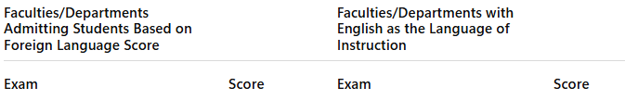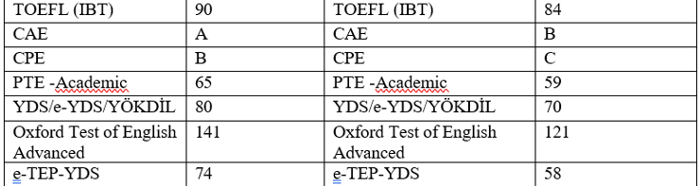 For the mentioned exams to be considered valid, they must have been administered by state universities in Turkey.
Important Notes for Students Before the Exam:
· Students must present a photo ID at the exam.
· Students must bring their own stationery materials (pencils and erasers); no other types of pens or tools are allowed.
· Students must arrive at the building at least 1 hour prior to the exam (09:00).
· Students must ensure their IDU student numbers are correctly filled in on the optical forms.
Exam Rules:
- The exam duration is 90 minutes. Students who arrive 15 minutes after the Listening section ends will not be allowed to enter the exam. (They may only enter during the first 15 minutes after the Listening section ends.)
- Students cannot leave the exam room for the first 45 minutes, under any circumstances. The last two students in the room must wait for each other to finish.
- Students are responsible for correctly coding their personal information and answers on the optical forms; otherwise, their exams will be invalid.
- Food and beverages (other than water) are not allowed.
- Do not share or request to share stationery materials (e.g., pencils, erasers).
- There are no restroom breaks during the exam.
- Talking or disturbing others during the exam is strictly prohibited. It is strictly forbidden to enter the exam with technological devices such as mobile phones, smartwatches, or earphones. Students found to be in possession of such devices during the exam will have their exam invalidated. If you have any such devices with you, you may hand them over to the invigilator in the exam hall before the exam begins. Otherwise, a disciplinary procedure will be initiated.
We wish all our students the best of luck!
School of Foreign Languages

